Responsibility
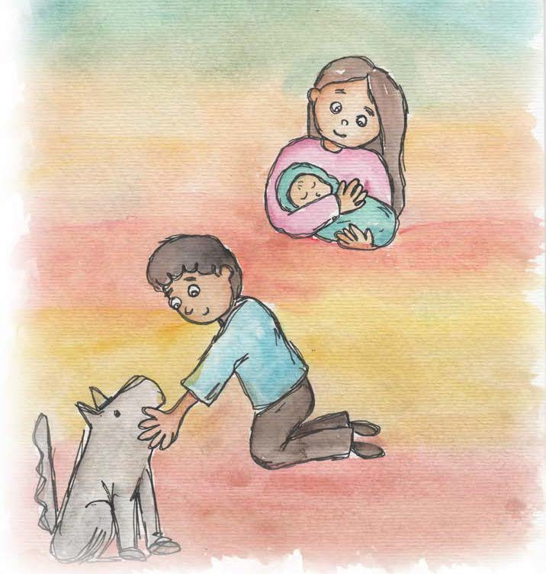
♦Responsibility is doing my job.

♦Responsibility is caring.

♦Responsibility is trying my best.

♦Responsibility is doing my share of the work.

♦Responsibility is taking care of things.

♦Responsibility is helping others when they need help.
♦Responsibility is being fair.

♦Responsibility is helping to make a better world.
From Living Values Education Activities for Children Ages 3-7 years © 2019
Association for Living Values Education International - www.livingvalues.net

